Comparison of ROC curve of LDA based face recognition with PCA based face recognition

**My dataset:** For each subject, use the first five images (1.pgm to 5.pgm) for training the subspace. Use the files 6.pgm to 10.pgm for the performance evaluation.

**PCA**

In project 1, I compute Euclidean distance between each image from test with images in their same subject from training set as genuine.

Computing Euclidean distance between each image from test set with images in different subject from training set as imposter. Due to the requirement, I only select one different subject randomly.

I get AUC=0.95185 and EER=0.1205 as a result and set it as a baseline for LDA.

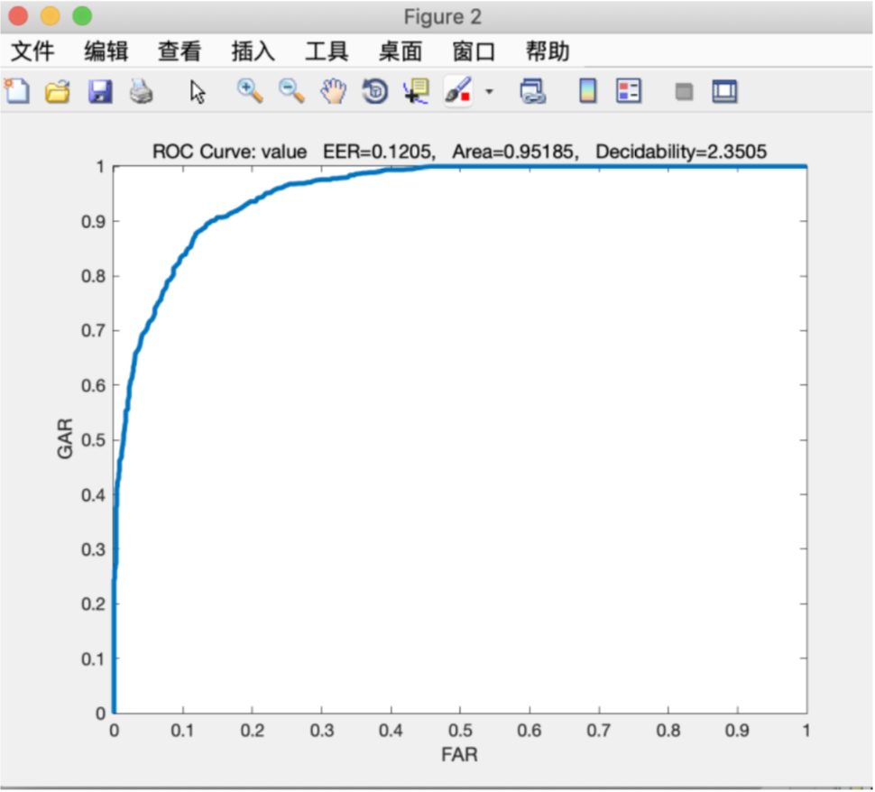

**LDA-1**

In project 2, I use the result from project 1 as a baseline to evaluate my model. To control variable or also called make a unified criteria, we have to use the same dataset we used in project1. The genuine dataset is as same as project1, but for imposter the dataset we obtained by selecting randomly , so maybe brings a little bias ,but the bias is not important for the result.

I get AUC=0.9656and EER=0.1075

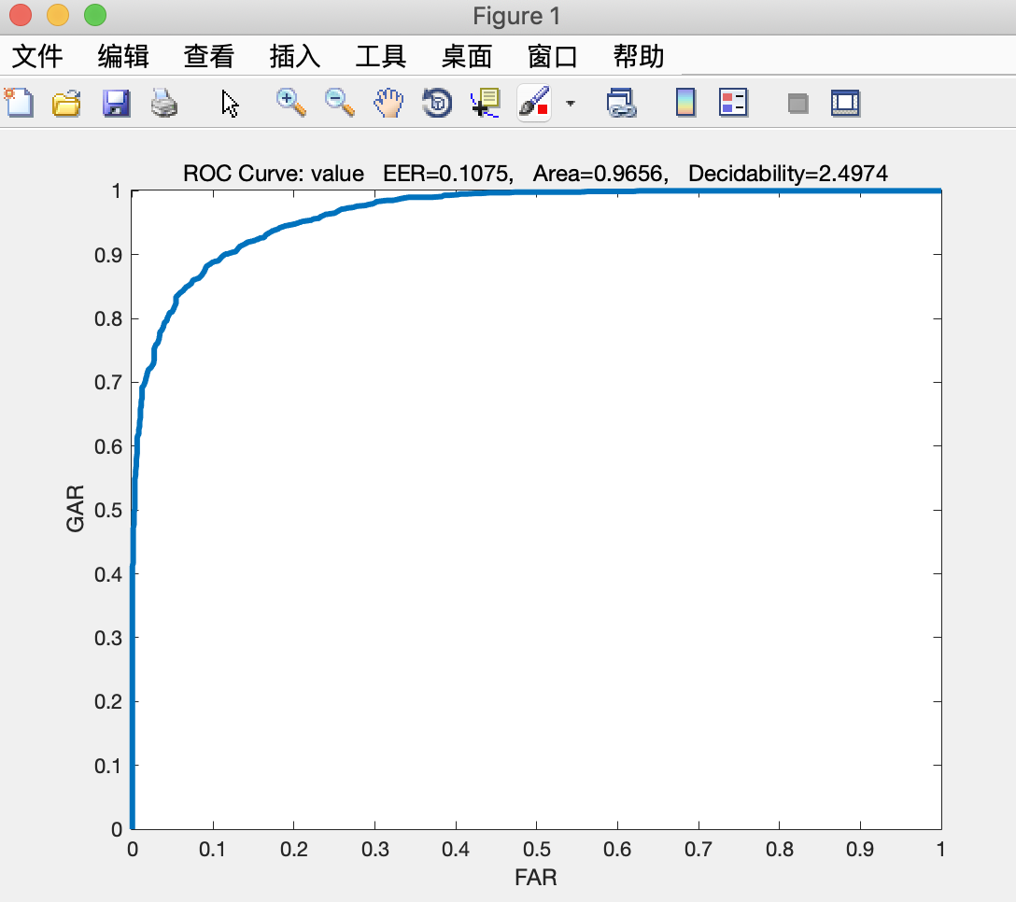

**LDA-2**

According to the requirement from LDA Project Assignment, we need to compare one subject from all remainder different subjects rather than random one, so I also do this by compare with remainder 39 subjects.

I get AUC=0.9697 and EER=0.0975

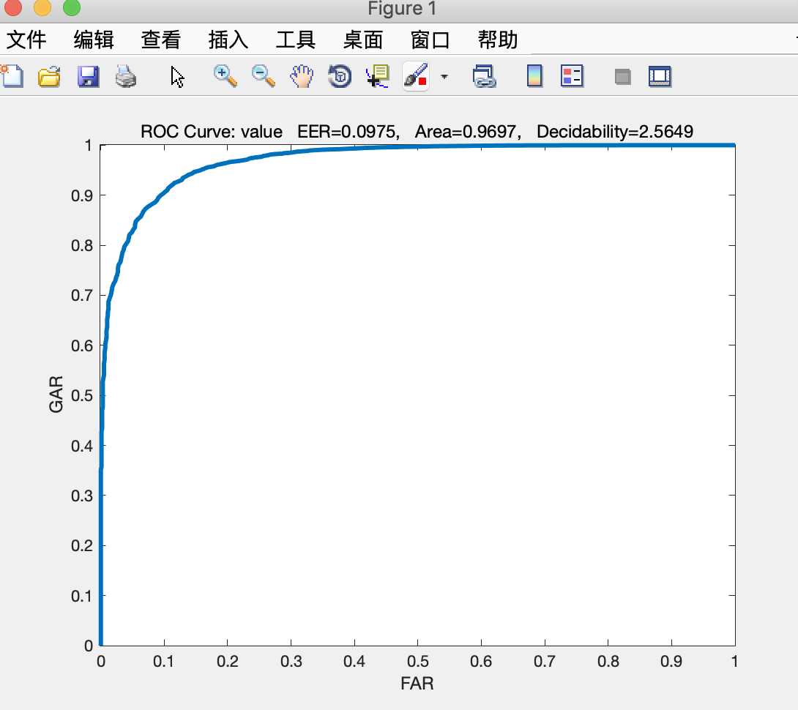

According these three different models by same dataset, we can find out that the LDA-2 (compared with all different images as a imposter) get the largest AUC area. Compared with LDA1, it trains lots of observation to improve the accuracy.

All in all, the conclusion is that if we do PCA(model1 ) before LDA(model2，3). The performance of LDA will be better than PCA. Because we combine PCA and LDA. LDA get worse performance if dimensionality is too high. So we use PCA to reduce dimensionality, based on PCA subspace the LDA performance has been a marked improvement.